

INDIAN INSTITUTE OF INFORMATION TECHNOLOGY ALLAHABAD

# IIVP632C COURSE PROJECT

**Automatic Road Extraction from Satellite Image**

# Submitted to :- Submitted by :-

Prof. Anupam Agrawal Ishan Arora (IIT2017501)

Vikrant Singh (IIT2017502)

Srikar Anand (IIT2017504)

Akshay Gupta (IIT2017505)

Naman Deept (IIT2017507)

# Contents

1. **Abstract 2**
2. **Introduction 2**
3. **Literature Review 3**
   1. Road detection from Satellite Images, International Journal of Applied Earth Observation and Geoinformation

(2007) . . . . . . . . . . . . . . . . . . . . . . . . . . . 3

* 1. Road Extraction from High Resolution Image with Deep

Convolution Network . . . . . . . . . . . . . . . . . . . 4

* 1. Automated Road Extraction from High Resolution Satel-

lite Images . . . . . . . . . . . . . . . . . . . . . . . . . 5

1. **Proposed Methodology 7**
   1. Models and Methods . . . . . . . . . . . . . . . . . . . 8
      1. Activation Function . . . . . . . . . . . . . . . . 8
      2. Image augmentation . . . . . . . . . . . . . . . 9
      3. Regularisation . . . . . . . . . . . . . . . . . . . 9
2. **Dataset 10**
3. **Base Paper 10**
4. **Activity Time Chart 10**
5. **Languages, Tools and Requirements 11**
6. **Conclusion 11**
7. **References 12**

# Abstract

This paper presents the project titled ”Automatic Road Extraction from Satellite Image” which aims to extract Road networks from Satellite images of the ground. This is more challenging compare to road extraction from the aerial images because satellite images are more noisy and comparatively of the lower resolution than the aerial images. Variety of the network structures with different number of the epochs or iteration times are used to train the model and to determine the model with best network structure so that results can be obtained with more accuracy.

**Keywords:** *artificial neural network, road extraction, deep convolution neural networks, satellite imaging, binary classification, image augmentation*

# Introduction

Road network detection is the process of detecting and extracting the road network from high resolution satellite images. It is essential for many applications like map generation and updating. To do this road network detection, resolution of satellite images plays an important role. If experts try to label the road pixels manually, it will take more time and will lead to errors. Hence an automatic method is proposed here.

Satellite images consist of the various parts of the earth and various other planet and stars which are taken through the use of the satellites. Satellite images provides the details about various natural and man-made features of the earth. These help in the various fields of studies like astronomy, agriculture, geology, etc. These are also used in google maps which help in finding and locating the different paths and locations. Road extraction from these images is one of the most important application as it can be of great help for the map, tourists, cabs, etc.

Road which is one of the most important man-made object, is a matter of the great concern for the researchers to be extracted as road extraction can be of great help. Lots of the researches have been done in this field. In the process of the road extraction, the first step can be road detection. This paper introduces the method in which road extraction has been done through the use of the artificial neural networks. This paper uses different type of the artificial neural network structures and test them using different hyperparameters.

# Literature Review

## Road detection from Satellite Images, International Journal of Applied Earth Observation and Geoinformation (2007)

Published in 2007, by International Journal of Applied Earth Observation and Geoinformation, authored by M. Mokhtarzade and M.J. Valadan Zoej, this article deals with the possiblity of using Artificial Neural Networks for detecting Roads from High-Resolution Satellite Images on a part of RGB Ikonos and Quick-Bird images from Kish Island and Bushehr Harbor. It was tested for various network structures with various iteration times and the best network structure and termination condition were selected.

One of the most important advantages of neural networks as compared to conventional statistical methods is that they are distribution-free operators, because the learning and recalling depend on the linear combination of data pattern instead of the statistical parameters of the input data.

In this paper the pixels of the input image were given as input to the Artificial Neural Network. The output is the pixels of output image, each being 0 (if not a pixel of a road) or 1 (pixel of a road). Overall accuracy is actually the percentage of correctly classified pixels to all available pixels in entire image. The networks are again tested across various number of hidden layers. More hidden layers help modulate more complex problems, but in this case the problem is just a low-complexity classification problem, number of hidden layers do not matter beyond a certain range, but only causes more training time. In [1], a back-propagation neural network was implemented with different hidden layer sizes trained with different iteration times to prevent over-training problem. It was found that there is no need to design more than 10 neurodes in hidden layer as it does not improve results noticeably. In fact, it makes the training and recalling stages more time-consuming.

## Road Extraction from High Resolution Image with Deep Convolution Network

This paper [2] which was named as ”Road Extraction from High Resolution Image with Deep Convolution Network” was published in March 2018 by National Engineering Laboratory for Transportation Safety and Emergency Informatics, and authored by Wei Xia, Yu-Ze Zhang, Jian Liu, Lun Luo and Ke Yang. In this paper the authors tried to make a Deep Convolutional Neural Network (DCNN) which would detect Roads in Satellite Images taken by the Satellite **GF-2**. The GF-2 satellite data is used for experiments, as its images may show optical distortion in small pieces. Experiments in this paper showed an accuracy of more than 80%.

The images of GF-2 satellite are quite prone to Optical Distortion. This paper aims to handle this problem mainly by the following ways. Firstly, inspired by the basic idea of big data, we try to use data of large scale and varied information, in order to gain different conditions; as many as possible. Secondly, we use DCNN methods with very deep layers to learn the abstract features from these conditions. In this experiment, GF-2 data of different locations and seasons in collected and divided into 256x256 sized images, producing thousands of images for training.

According to the experiments, a total correctness of approximately 80% can be obtained through our proposed method.

## Automated Road Extraction from High Resolution Satellite Images

This paper was produced in International Conference on Emerging Trends in Engineering, Science and Technology (ICETEST - 2015) authored by Jose Hormese and Dr. C. Saravanan . In this paper they illustrated a novel approach to road extraction from satellite images using vectorisation approach which mainly applied through 3 steps.

1. the image is segmented to roughly identify the road networkregions
2. the decision making and continuity procedure to correctly detectthe roads
3. the Vectorization step to identify the line segments or curvedsegments which represent the roads segmentation .

The vectorization approach is an automatic method in extracting road segments from satellite images. The method adopted is to identify the road segments which are represented as continuous line segments as the road could be of any arbitrary shape. The start and end points of each line segment is identified and the road segments in the image are correctly extracted.

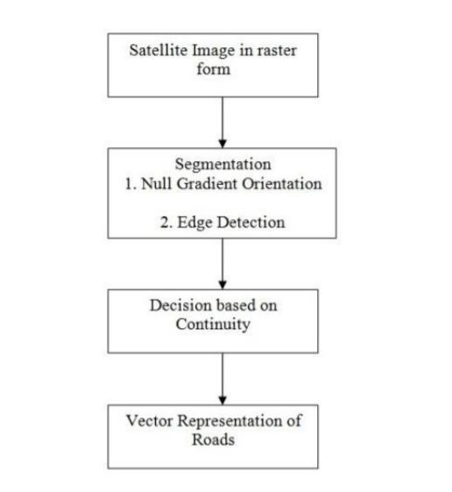

Figure 1 : Automated Road Extraction Flow Diagram

In this paper they cite that this method was more suitable for the rural images as compared to urban areas where man-made objects are less so roads detection are easy . Through segmentation , decision making based on continuity and vectorization procedure the raster satellite images can be converted to vector representation and it is possible to extract roads from satellite images .

# Proposed Methodology

In this paper we shall be using a Deep Convolutional Neural Network (DCNN) which shall take input as the pixels of the input image and produce the output of pixels’ values which shall form an image. Deep Convolutional Neural Networks provide a satisfactory result for identifying the road from satellite images. The advantage of Convolutional Network is that it will be able to work on the images of any size, varying from a small block of road to satellite image of a large city. There are two approaches that can be implemented with this ANN.

First one is the Binary Classification approach, in which each output pixel in labelled as 0 (Background pixel) or as 1 (Road pixel) according to the corresponding input pixel. In this binary segmentation the spatial tolerance is zero.

The second approach however has non-zero spatial tolerance that is adjustable. This is a regression based approach. In this, each output pixel has a value between 0 and 1 that represents how close or how probable that the pixel is a road pixel. The idea is to give a even target distribution that is centered along the road labels, having a maximum value of one that is assigned to the road labels which uniformly decreases to zero for the background other than the roads. We may use softmax function for this approach.

Another third approach is similar to the second one, in which sigmoid output is taken with a threshold value, generally **0.5**.

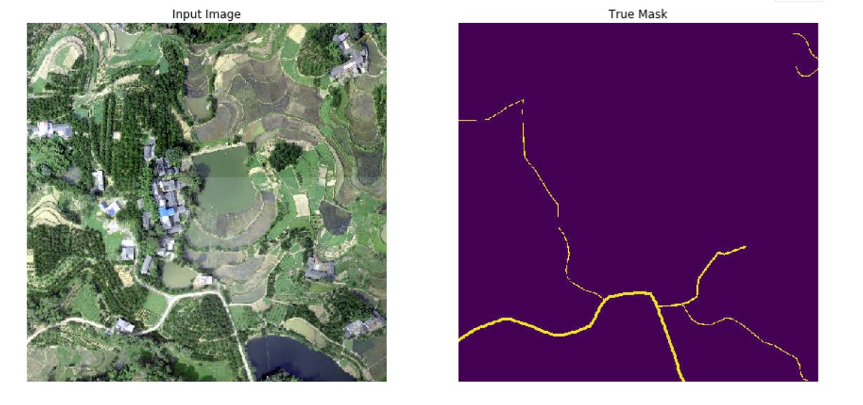

Figure 2 : Sample Input and Output images produced by the first method (Binary classification of pixels)

## Models and Methods

CNN based models would be the best choice for such a problem since CNN based model provide excellent results with problem involving image classification and segmentation.

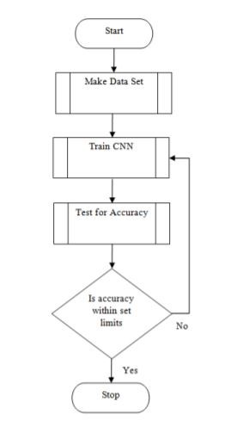

Figure 3 : CNN based models

### Activation Function

RELUs are the standard choice for the deep learning neural networks , however , when a high learning rate is used some units get stuck which arise dead-filters. For this reason , another variant called *leaky RELU* is used to come around the solution .

### Image augmentation

If the dataset is small then image augmentation will be used to virtually increase the size of the data-set. Specially before being supplied to neural network wherein each training sample is rotated by 90◦ ,

180◦.

### Regularisation

Although data augmentation helps in reduce overfitting , Dropout layers are being added which always have been effective way to reduce the overfitting problem in such situations.

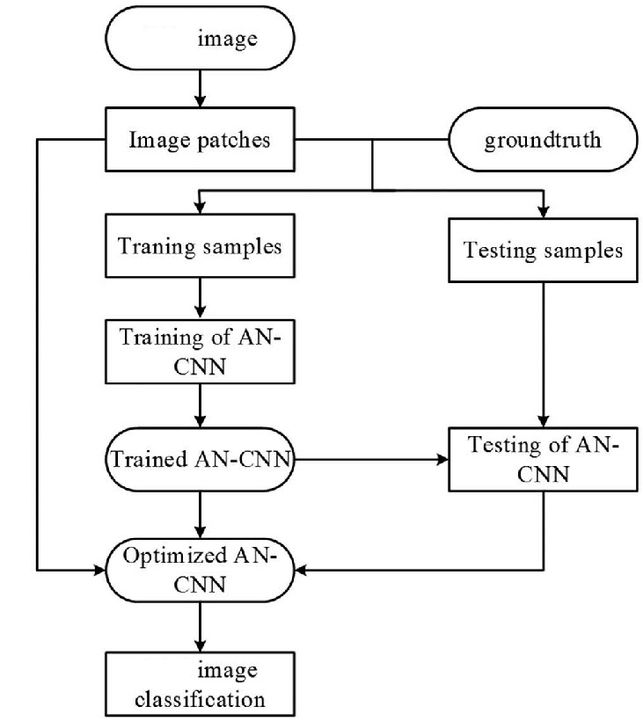

Figure 4 : CNN based model solution

After all these procedure final results are cross-validated and accuracy of the model is calculated to test how was the performance of the said procedure.

# Dataset

We will use the dataset available from the following two sources:

* Satellite Road Segmentation by Wurenzhe:

https://www.kaggle.com/wurenzhe/satellite-road-segmentation

* EPFL ML Road Segmentation:

https://www.kaggle.com/c/epfml-segmentation/data

# Base Paper

The base paper to be used by us for the implementation will be ”Road detection from high-resolution satellite images using artificial neural networks” by M. Mokhtarzade and M.J. Valadan Zoej. The reference for the same is given in [1].

# Activity Time Chart

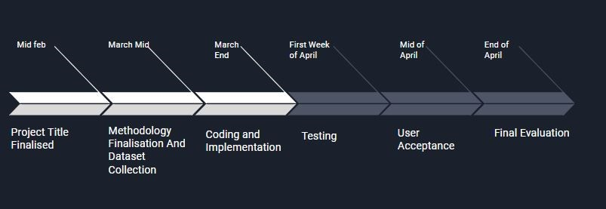

Figure 5 : Project Timeline

* Project Title - Start of February
* Literature Review, Problem Statement, Formulation and Report - Mid-February
* Finalizing Methodology - End of February
* Understanding and learning concepts and technologies required

- First week of March

* Dataset Collection - First week of March
* Coding and Implementation -2nd Week of March to Mid April
* Testing and Improvement - End of April

# Languages, Tools and Requirements

* Python 2,3
* Keras , Tensorflow , OpenCV and PyTorch Libraries
* Operating System - Linux (Ubuntu) or Windows
* Intel i5 or above processor
* RAM - 8GB minimum

# Conclusion

The Deep Convolution Neural Network proposed here contains multiple feature for road classification that can be done either through supervised learning or the unsupervised learning based on the kind of available data-sets . Through various research methodologies that has been studied , the Convolutional Neural Network is found to be the best in context for the image recognition system .The results shown in the base paper can be further improved using image enhancement techniques (like histogram equalization) ,So basically we are adding an extra layer to our base paper which will lead to more precise output (fine tuning and image enhancement). The main concept can also be extended to adjusting the values of hyper-parameters like learning rates ,kappa coefficient values and the error coefficient (value k in E = k||*L*||2) in our basic training of convolutional neural networks .

# References

1. Sample Input and Output images produced by the firstmethod (Binary classification of pixels)[Online Image] Retrieved February 14,2020 from URL https://www.kaggle.com/wurenzhe/satellite-road-segmentation
2. M. Mokhtarzade and M.J. Valadan Zoej, ”Road detection from high-resolution satellite images using artificial neural networks”, International Journal of Applied Earth Observation and Geoinformation, 2007 32-40
3. Wei Xia, Yu-Ze Zhang, Jian Liu, Lun Luo and Ke Yang,”Road Extraction from High Resolution Image with Deep Convolution Network—A Case Study of GF-2 Image”, 22-March-2018, National Engineering Laboratory for Transportation Safety and Emergency Informatics, China Transport Telecommunications Information Center, Beijing
4. Jose Hormese , Dr. C Saravanan, ”Automated Road Extraction From High Resolution Satellite Images”, National Institute of Durgapur , International Conference on Emerging Trends in Engineering, Science and Technology (ICETEST - 2015)
5. Jose Hormese , Chandran Saravanan ,”A CONVOLUTIONAL NEURAL NETWORK APPROACH TO ROAD CLASSIFICATION FROM SATEL-

LITE IMAGES ”, Journal of Theoretical and Applied Information Technology ,15th December 2018. Vol.96. No 23

1. P. Yadav and S. Agrawal, ”ROAD NETWORK IDENTIFICATION AND

EXTRACTION IN SATELLITE IMAGERY USING OTSU’S METHOD AND CONNECTED COMPONENT ANALYSIS”, GIS Cell, Motilal Nehru National Institute of Technology Allahabad,The International Archives of the Photogrammetry, Remote Sensing and Spatial Information Sciences, Volume XLII-5, 2018 ISPRS TC V Mid-term Symposium “Geospatial Technology – Pixel to People”, 20–23 November 2018, Dehradun, India

1. Corentin Henry, Seyed Majid Azimi and Nina Merkle, ”Road Segmentation in SAR Satellite Images With Deep Fully Convolutional Neural Networks”, IEEE GEOSCIENCE AND REMOTE SENSING LETTERS, VOL. 15, NO.

12, DECEMBER 2018